# Noor Al Salihi

Module 2.3 – Data Models  
CSD-310  
Date: 10/30/2025

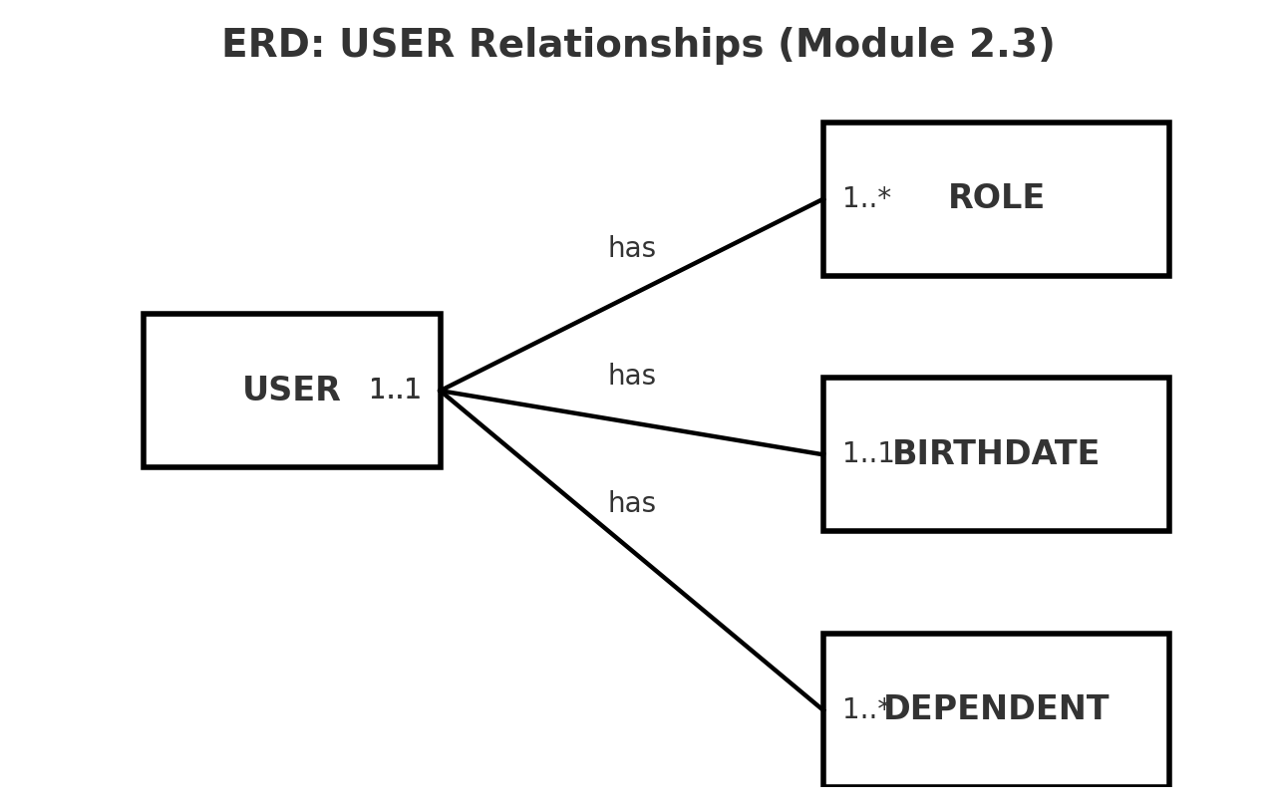

**Figure 1. ERD with 3 business rules: USER to ROLES 1..*, USER to BIRTHDATE 1..1, USER to DEPENDENTS 1..*.**

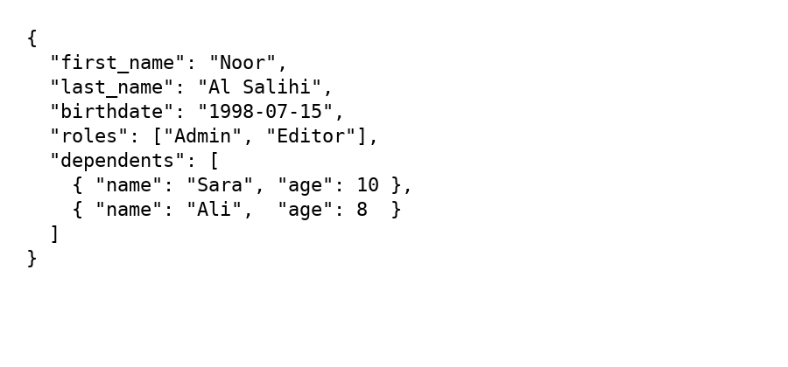

Figure 2. NoSQL JSON document representing a USER with an embedded array of roles and an embedded array of dependents (NoSQL embedded documents).